LICHFIELD SOCIETY OF ARTISTS

AUTUMN EXHIBITION 24th to 28th April 2026

ENTRY FORM
Entries are accepted from LSA members only, deadline for entries 17th April 2026
Return completed forms to: Sasha Lauer, 25 Wissage Lane, Lichfield, WS13 6DQ
Email: sasha.lauer@btinternet.com
Handing in time: 08:30 to 10:00, Friday 24th April 2026, at the Guildhall, Lichfield.
Awards Ceremony 10:00 Saturday 25th April (Please attend if you can!)
Collection of work 16:00 to 17:00 Tuesday 28th April 2026.
Works may not be removed before this time. We cannot guarantee the safety of uncollected work. If you are unable to make collection yourself, please make sure someone else can do so.
Name (as you would like it on the exhibition label)
Address
Email /
Telephone
Fees must be paid at the time of entry:
BACS (preferred): Lichfield Society of Artists, 30-90-09, 50760360, Ref: EXH ENTRY
Cheques made payable to Lichfield Society of Artists should be posted with your application form.
Framed works and block canvasses (maximum 3 items) Fee per item: under 20”/50cm £5; up to 27.5”/70cm £8; over 27.5”/70cm £11. Please see diagram below for presentation of frames.
Title | Medium | Dimensions | Price £ | Fee £
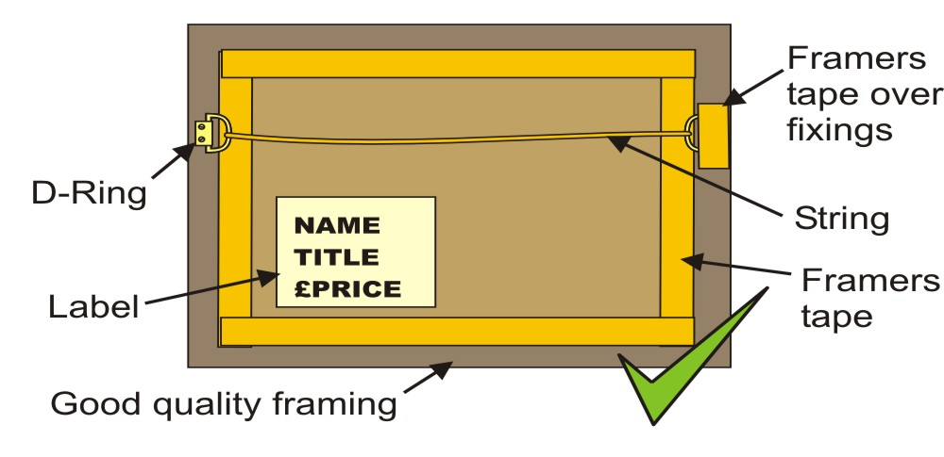
Frames with single hooks or side brackets cannot be hung and will not be accepted.
Unframed block canvasses must be painted to and around the edges.
3D works, Ceramics, Sculpture Fee per item: Small items less than 8”/20 cm £3 or £10 for 5 items. Larger items (max 3 items) £8. Note that works larger than 24”/60cm will require proof of public liability insurance.
Title | Medium | Dimensions | Price £ | Fee £
1.
2.
3.
4.
5.
Browser, Fee £2 each for unframed works, max 5 items (no canvasses accepted)
Items should be labelled on back with name of artist, title and price.
Title |  | Medium | Price £ | Fee £
1.
2.
3.
4.
5.
The Art Shop
Small items such as cards, miniature paintings (framed or mounted), fabric items, miniature ceramics, jewellery etc. can be entered for sale without fee but subject to 20% commission.
I will be bringing a selection of items for the shop yes / no (delete as appropriate)
Items should be clearly labelled with price, initials and code number. We require a hard copy proforma listing your items and codes so we can keep track of sales. This should be submitted on Hand In day with your items. The proforma may be downloaded from the LSA website or requested from Sasha Lauer.
Stewarding
All exhibitors (or a proxy) are expected to steward at least once. Please circle at least three time slots from the list below and we will email or phone to confirm your slot.
Friday 24th April 13:00-15:00, 15:00-17:00
Saturday 25th April 09:00-10:00, 11:00-13:00, 13:00-15:00, 15:00-17:00
Sunday 26th April 10:00-12:00, 12:00-14:00, 14:00-16:00
Monday 27th April 09:00-11:00, 11:00-13:00, 13:00-15:00, 15:00-17:00
Tuesday 28th April 09:00-11:00, 11:00-13:00, 13:00-15:00, 15:00-16:00
This is my first time exhibiting with the LSA: Yes / No (delete as appropriate)
I have submitted payment of: £___________ by BACS / Cheque (delete as appropriate)
I have read, understand and agree to the terms and conditions.
Signed:__________________________________

Terms and Conditions
Insurance
One of the benefits of membership of the society is that it enjoys public liability insurance cover when you exhibit your artwork in an exhibition organised by the society. However, individual items are not covered against theft or damage and need to be separately insured by the artist if required. Also, 3D items larger than 24” or too heavy to be moved by a single person are not covered; members submitting large items are required to organise their own public liability insurance and should forward a copy with the entry form.

General Exhibition Rules and conditions of entry
Artwork:
- must be of a size that can be accommodated in the space available.
- must comply with all national and international copyright legislation.
- must not contain pornographic material.
- must be the exhibitor’s own original work (i.e. not a reproduction). However, artists prints (relief, intaglio etc) may be exhibited and should be signed and numbered with the print run (e.g. 1/10) or artists’ proof. Digital art work should be printed out on quality paper and framed for exhibition. Print reproductions of original work may only be displayed in the browser or shop.
- must be new work, and not shown in previous LSA exhibitions.
Presentation
Exhibits should be submitted at the Guildhall, Lichfield on 24th April between 08:30 and 10:00. They should be unwrapped and clearly labelled on the back with the title of the work, price and artist’s name. Works not intended for sale should be clearly marked “NFS”. Work cannot be accepted if not labelled.
Unframed paintings for the browser should be mounted, wrapped in clear film, and clearly labelled on the back with artists name, the title and the price.
Items for the art shop must be clearly labelled with price, initials and a code number and a list of the items with the same information should be submitted with your items at hand in so that stewards can record sales. A proforma may be found on the LSA website or requested from the exhibition organiser.
Picture frames must be fitted with ‘D’ rings and properly strung. Frames with a single centre hook cannot be accepted as it is not possible to hang them. Presentation, mounting, and framing MUST be of a high standard. Glazed frames should be sealed with framing tape which should also cover the fixings.
Unframed block canvasses must be painted to and around the edges.
Stewarding
It is a condition of entry for main exhibitions that exhibitors may be called upon to act as stewards at least once during the exhibition. Another person may be nominated to steward in the exhibitor’s place. Availability for stewarding should be indicated to the exhibition organiser at the time of entry.
Removal of Exhibits
Unsold Exhibits may only be removed between 16:00 and 17:00 on 7th October. The Society cannot be held responsible for artwork not collected. Uncollected work may be subject to a handling fee. Work not collected within 6 months of exhibition end may be disposed of.
All works sold during the exhibition will be subject to sales commission of 20% of the sale price. Payment for sales will be made within 30 days of the close of the exhibition.

